**The Islamia University of Bahawalpur**

**Department of Computer Science**



**SOFTWARE DESIGN DESCRIPTION**

**(SDD DOCUMENT)**

**for**

**Online Medicine Search**

##### Version 1.0

***By***

**M. Wasif Rehan**

**FA19M2BA094**

**Session Fall 2019 – 2023**

***Supervisor***

**Mam Urooj Fatima**

***Bachelor of Science in Computer Science***

Table of Contents

**Introduction 1**

**Design methodology and software process model 5**

**Software requirements traceability matrix 7**

**System overview 1****6**

**Design models [along with descriptions] 17**

**Data design 2****9**

**Algorithm & Implementation 35**

**Human interface design 3****6**

**Appendix I 47**

**Revision History**

|  |  |  |  |
| --- | --- | --- | --- |
| **Name** | **Date** | **Reason for changes** | **Version** |
| M.Wasif Rehan | 26-12-2022 |  | 1.0 |
|  |  |  |  |

**Application Evaluation History**

|  |  |
| --- | --- |
| **Comments (by committee)**  **\*include the ones given at scope time both in doc and presentation** | **Action Taken** |
|  |  |
|  |  |

**Supervised by**

**Mam Urooj Fatima**

Signature

**Chapter 1** **Introduction**

## Purpose

The objective of this document is to provide details and description about the project or software system called “Online Medicine Search”. This reports its features, functional, and non-functional requirements. This document answers to the questions; What will be the interface, how system will work, and what could be constraints to users? The stakeholders of this platform or website are Medical Store owner and common peoples.

## Scope

This project is an online medicine search web application. This application allows a visitor to search for a medicine and addresses of medical stores (wholesale and retail sales) where the medicine is available**.** Medical Stores can put their medicines and personal info for visitors.

## Definitions, Acronyms, and Abbreviations.

ASP.NET: Active server Pages, a framework for building web apps and services with .NET and C#.

IEEE: Institute of Electrical and Electronics Engineers.

## References

IEEE 830-1993 standard format is followed.

## Overview

In section 2, functionalities of the system is defined as in natural language easy understandable to the user. In section 3, each functionality is elaborated so that it could be helpful for the developers as well. Functionalities are written in sequence with perspective of three users. i.e Admin, Medical Store member, visitor

## Product Perspective

This “ONLINE MEDICINE SEARCH” is an online medicine search web application. This application allows a visitor to search for a medicine and addresses of medical stores (wholesale and retail sales) where the medicine is available.

Main need of the client is to prepare an online application to help the needy people in finding the availability of the medicine and a list of medical stores where the medicine is

available. The visitor can quickly find the nearest medical store by selecting the area in the search tools.

This application also provides a login account to a registered medical store. Using this account a person from the medical store can update the list of medicines and their stock on daily-wise. This avoids providing outdated data to the visitor.

### System Interfaces

* + - * Public Pages Module
      * Medical Store Module
      * Medicine Search Module
      * Admin Module (Operator)

### Interfaces

Our application’s all interfaces will be user friendly and user can perform these above functionalities easily.

### Hardware Interfaces

* + - * Machine: 32bit OR 64bits.
      * CPU: at least ability to run latest operating system with internet Connection.
      * RAM: 512MB OR 1GB .
      * Disk: 1GB

### Software Interfaces

* + - * Operating System: Windows Server
      * RDBMS: Sql Server
      * Web Browser: Internet Explorer
      * Web Server: IIS
      * Technology: ASP.NET
      * Languages used: C#.NET

### Communications Interfaces

The means of communications will be through web services.

### Memory Constraints

* + - * RAM: 512MB OR More.
      * Disk: 1GB

### Operations

None.

### Site Adaptation Requirements

None.

## Product Functions

**Public pages module:**

These modules are useful in providing information to a visitor (login is not required) about the website and contact address and numbers. The homepage displays the main features of the website.

**Medical store module:**

These modules can do add a new medicine to list, manage existing Medicines List, and edit or Update medicines stock and maintain the application settings **Medicine search module:** This module can do for Search and advanced search for search results and search results filtration

**Admin module (Operator):**

These modules allow an administrator of the website to manage cities and manage master data. And also provide Manage Medical Store User Accounts.

## User Characteristics

The user of our system is not necessary to be technical expert. Our system user education level is no specified but he will be aware of surfing internet. Anyone can use our system easily.

## Constraints

The system must have an internet connection with compatible browser like Google chrome, Firefox and Mozilla etc.

## Assumptions and Dependencies

Our application will be hosted on the cloud enviourment . Our main issue that may occur and effect our requirement will be the load of traffic will be handle in the long run with the help of load balancer.

## Apportioning of Requirements

This application should be update due to new secure algorithms or new version of the Database adding the new reliable functionality.

**1.12 Design Methodology**

Object-oriented programming (OOP) is a programming methodology that is based on the concept of "objects", which can contain data and code that manipulate that data. These objects are defined by classes, which specify the characteristics and behaviors of the objects.

In OOP, objects interact with each other through methods, which are functions that are associated with a particular object. This allows for a more modular and organized approach to programming, as each object can be treated as a self-contained unit with its own specific set of responsibilities.

OOP also includes the concept of inheritance, where a class can inherit the characteristics and behaviors of another class, allowing for code reuse and modularity.

Overall, OOP helps developers create more efficient and scalable code by organizing it into modular units and allowing for code reuse through inheritance.

**1.13 Software Process Model**

**Waterfall Model**

The Waterfall Model is a software development methodology that follows a linear, sequential approach. It is based on the idea that each phase of the development process must be completed before moving on to the next phase.

The Waterfall Model consists of the following phases:

Requirements gathering and analysis: This phase involves gathering and analyzing the requirements for the software. This includes identifying the user needs, defining the scope of the project, and creating a detailed specification of the software.

Design: In this phase, the software architecture and design are created. This includes designing the user interface, determining the system's overall structure, and creating a detailed design document.

Implementation: In this phase, the software is actually developed and coded. This includes writing the source code, testing it, and debugging any errors.

Testing: In this phase, the software is tested to ensure that it meets the requirements and functions correctly. This includes functional testing, integration testing, and acceptance testing.

Deployment: In this phase, the software is installed and made available for use. This includes installing the software on the target system, configuring the system, and training users on how to use the software.

Maintenance: In this phase, the software is maintained and updated as needed. This includes fixing any bugs or issues that are discovered, and releasing new versions of the software.

**Waterfall model:**

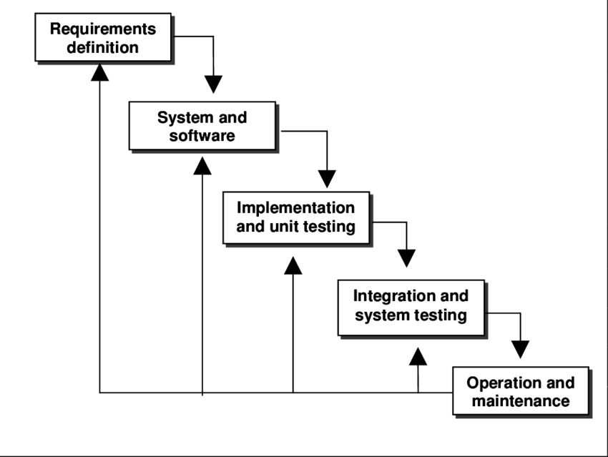

# Chapter 2

**Software Requirements Traceability Matrix**

## Specific Requirements

This section contains all the software requirements at a level of detail sufficient to enable designers to design a system to satisfy those requirements, and testers to test that the system satisfies those requirements. Throughout this section, every stated requirement should be externally perceivable by users, operators, or other external systems.

## Functional Requirements

|  |  |
| --- | --- |
| 1 | Medical Store Admin |
| 2 | Admin (Operator) |
| 3 | Visitor |
| 4 | Registration |
| 5 | Login |
| 6 | Logout |

### Medical Store Admin

|  |  |
| --- | --- |
| Description | The user Medical store admin will be able to create account on our application then account credentials will be given to the store admin using these credentials he will be able to perform crud functionality of medicines of his own medical store. |
| Inputs | Medical store admin creates his/her store and add medicine to the store. |
| Processing | Data is stored in Database |
| Outputs | Medicines and store details will display on medical store admin panel. |
| Error Handling | All Errors will be handled by Exception handling in ASP.Net. |

### Admin (Operator)

|  |  |
| --- | --- |
| Description | Main Admin (Operator) will be able to block or unblock user medical store admin on the basis of his/her activities. |
| Inputs | Main Admin(operator) uncheck the role of (medical store admin). |
| Processing | Medical Store Admin role change in database. |
| Outputs | Display all user details with new roles on Admin panel. |
| Error Handling | All Errors will be handled by Exception handling in ASP.Net. |

### Visitor

|  |  |
| --- | --- |
| Description | Visitor visit our application and he/she will be able to search medicines and medical stores. |
| Inputs | Search parameters will be passed through search bar etc. |
| Processing | The Searching will be done according to passed parameters and prepared for view. |
| Output | Result will show on web page. |
| Error Handling | All Errors will be handled by Exception handling in ASP.Net. |

### Registration

|  |  |
| --- | --- |
| Description | Medical Store Admin once must be register oneself firstly. After registration he/she can create medical store and add medicines |
| Inputs | Customer provides the basic information about the user like name, email, content number, password. |
| Processing | Received data from the user in text fields and save in database  . |
| Outputs | Display login page. |
| Error Handling | All Errors will be handled by Exception handling in ASP.Net. |

### Login

|  |  |
| --- | --- |
| Description | System will create the login page for the user. User provides the basic information and visit his/her panel. |
| Inputs | User will provide the valid email and password and login into his/her login. |
| Processing | * System received the data from text fields. * Database will verify the data according to the requirements. |
| Outputs | Display required panel. |
| Error Handling | All Errors will be handled by Exception handling in ASP.Net. |

### Logout

|  |  |
| --- | --- |
| Discerption | After adding medicines medical store admin will logout |
| Inputs | Click on logout button. |
| Processing | Logout function call when hit the logout button. |
| Outputs | System will show you have logout. Display home screen |
| Error handling | All Errors will be handled by Exception handling in ASP.Net. |

## Functions

* Search medical store by the area
* Search for the medicine by the name
* Add medicine by the store admin
* Medicine is updated or deleted by the store admin
* Register medical store on our server

## Performance Requirements

The developed system must be interactive and must have as less as delays. It responds to every kind of situation. It works and response efficiently. It should provide the fast response of each activity of the application.

## Logical Database Requirements

This section specifies the logical requirements for any information that is to be placed into a database. This may include:

* Medicine data stored in database
* Login and Registration Information of the user is stored in database
* All the activity performed by user
* Login and Registration relationship with users
* Any necessary field could not be null.
* Constrains are applied to all fields.

## Design Constraints

* HTML, CSS, JavaScript, Adobe Photoshop, bootstrap used for the activities
* Web design Is responsive in any kind of mobile device and laptop PC.

### Standards Compliance

* + - * This Web application is free available for user
      * No standard charges apply usage of database.

## Software System Attributes

## Reliability

The online medicine search web application shall provide reliable information of medicine because of the verified information of the admin at the time of registration.

### Availability

If internet service gets disconnected while sending information to the server, the information can be send again as internet get available with verification. And the system will be available for general public to use. Means if user update the application and internet service gets down then after the internet connectivity the application should be update.

### Security

The main security concern is for users account hence proper login mechanism should be there to avoid any kind of unauthorized authentication. So there should be highly security checks on every operation so that user can feel free to give their data. Users data is secure. Safe from unauthorized accesses because of separate portals.

### Maintainability

Maintainability means that the system can be maintainable once it constructed or developed. It means that there should be room for maintenance if any of conflict is occurred in the system after developing. And requirement should be change with the passage of time.

### Portability

The Online medicine search web application shall be accessed by any window or Linux system.

# Chapter 3

# System Design and Architecture / System Overview

## Architectural Design

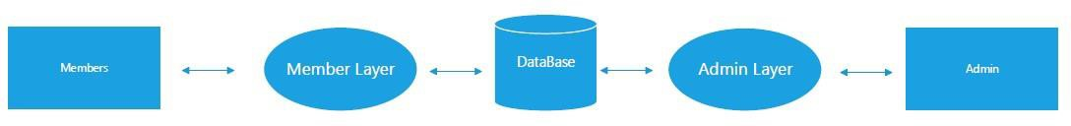

## Decomposition Description

### Use case Diagram of Online Medicine Search

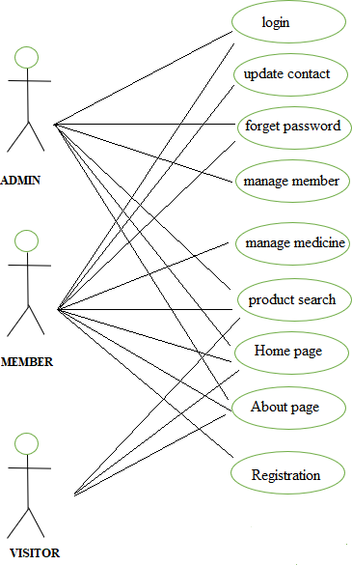

### Use case Diagram of Admin

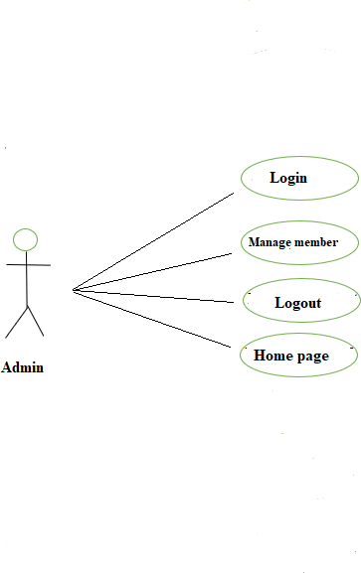

### Use case Diagram of Member

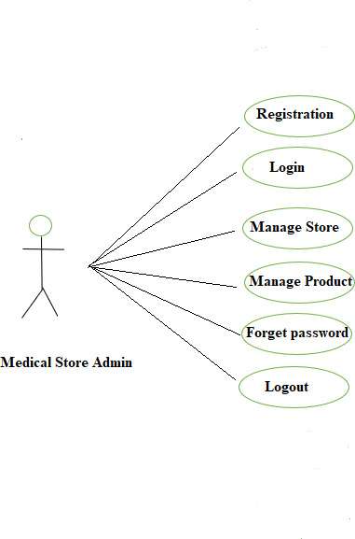

### Use case Diagram of Visitor

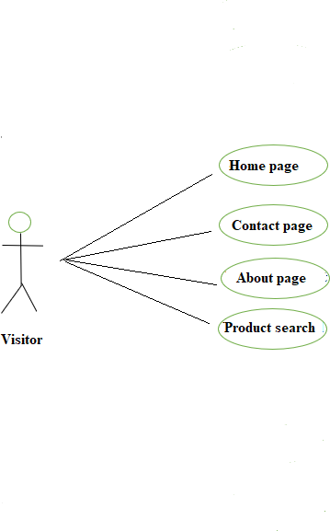

### Level 0 (Data Flow Diagram)

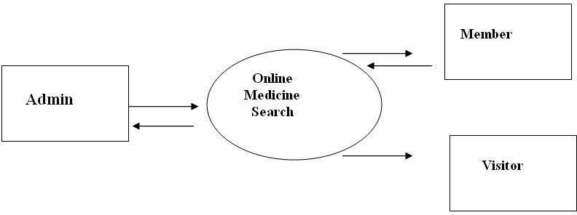

### Level 1 (Data Flow Diagram)

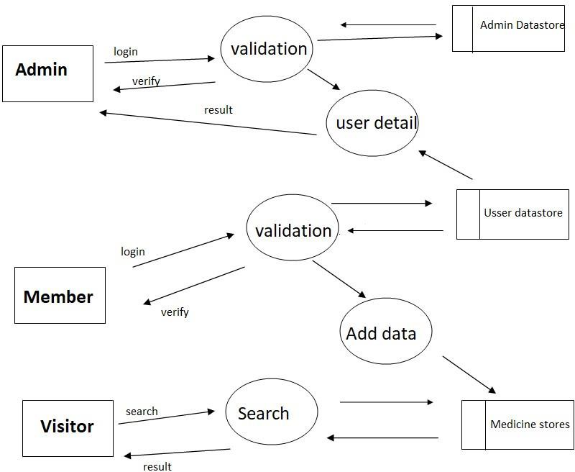

### Activity Diagram for Admin

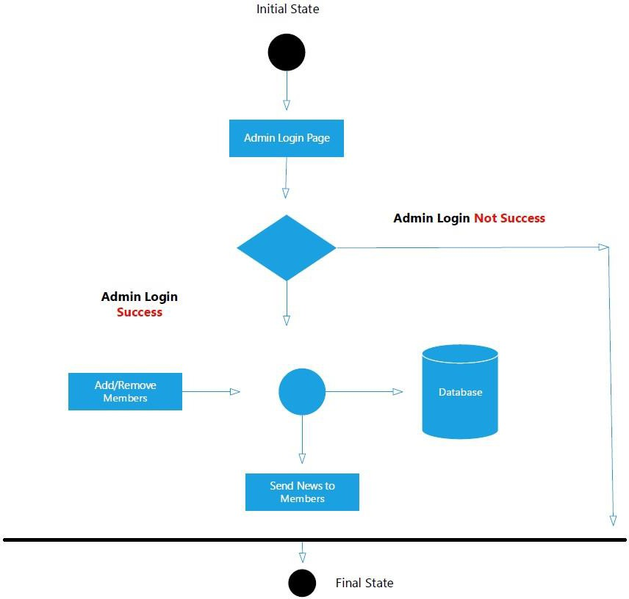

### Activity Diagram for Medical Store Member

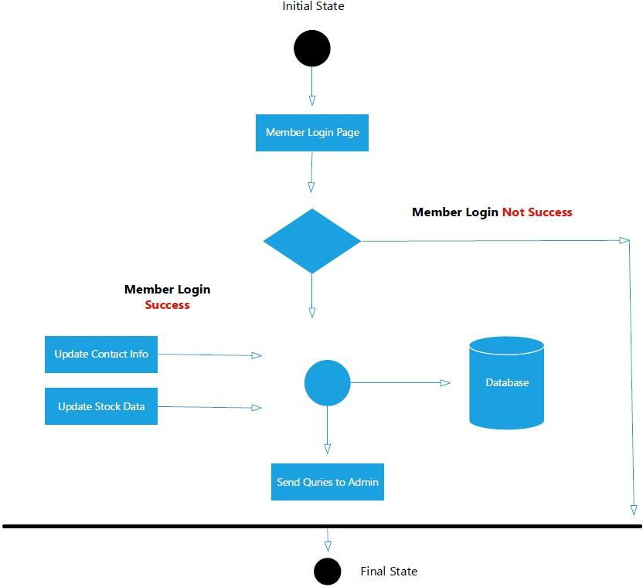

### Login Sequence Diagram

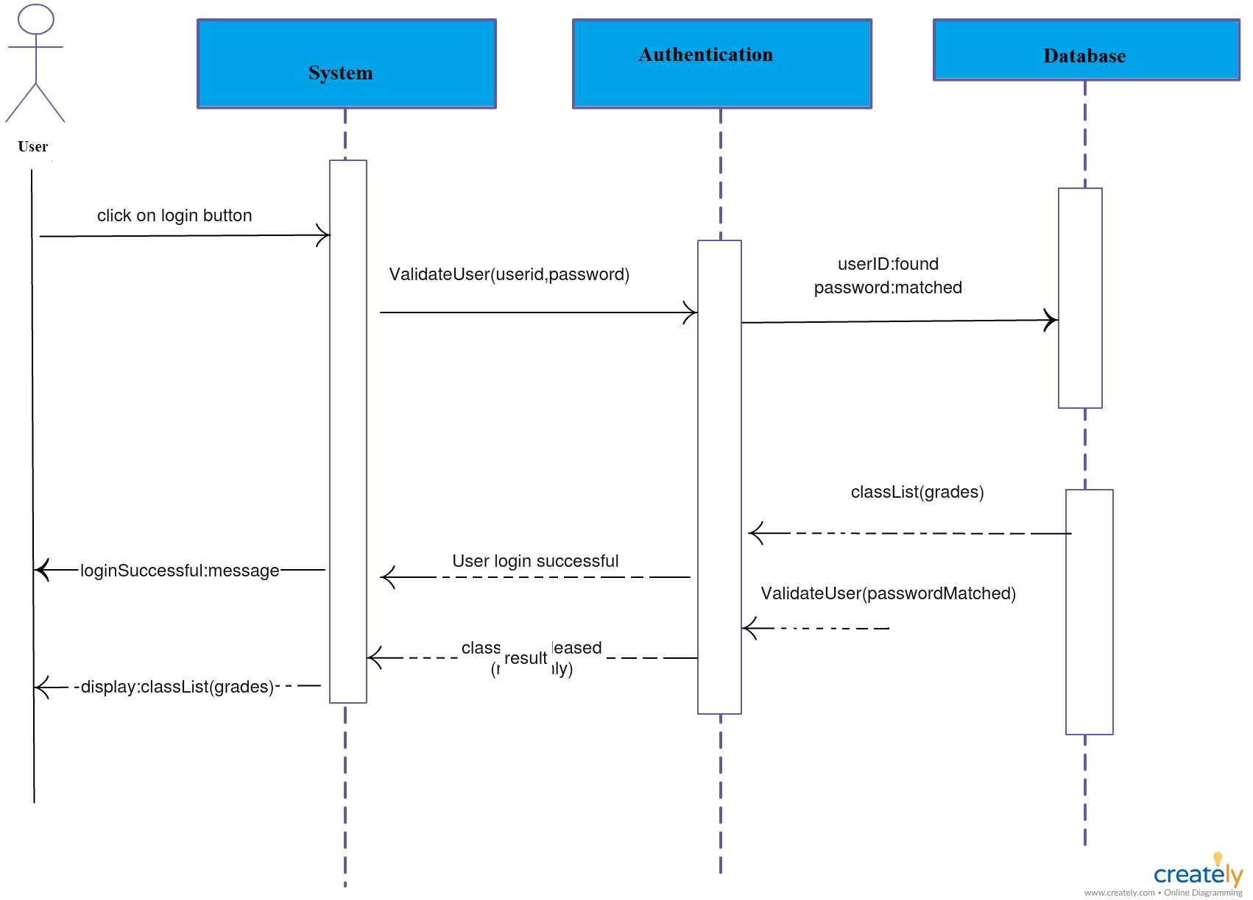

### Sign up Sequence Diagram

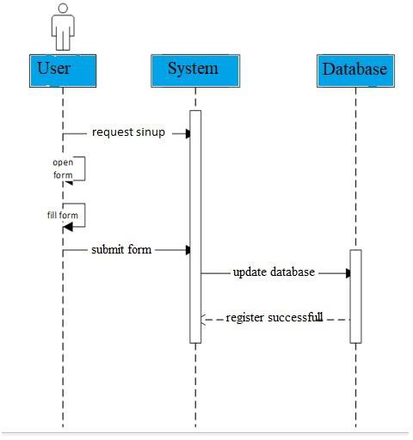

### Add Medicine Sequence Diagram

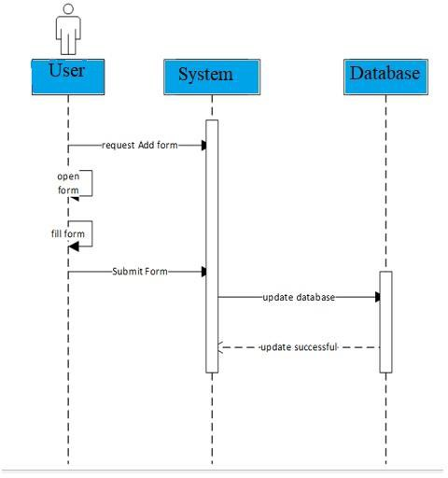

## Design Rationale

### ER Diagram

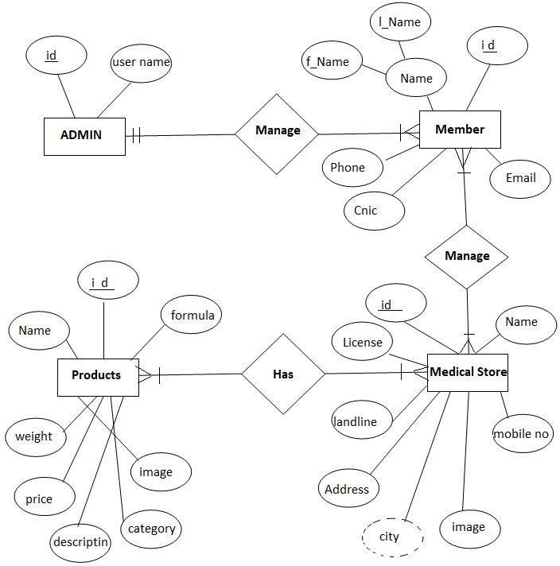

## Data Description / Design

**Table_User**

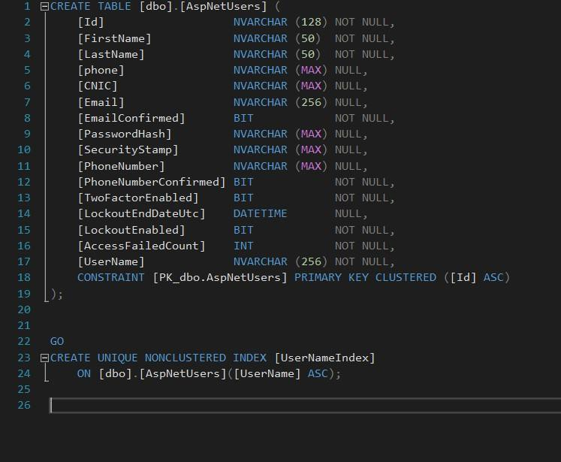

**Table_Product**

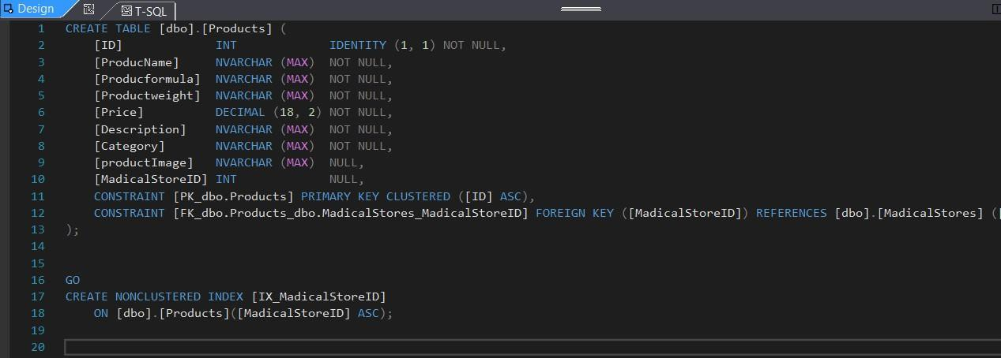

**Table_Roles**

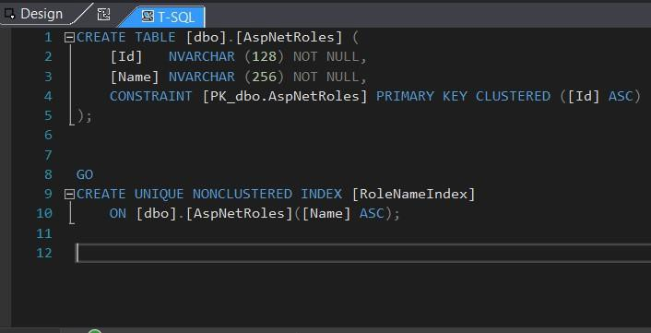

**Table_Medical Store**

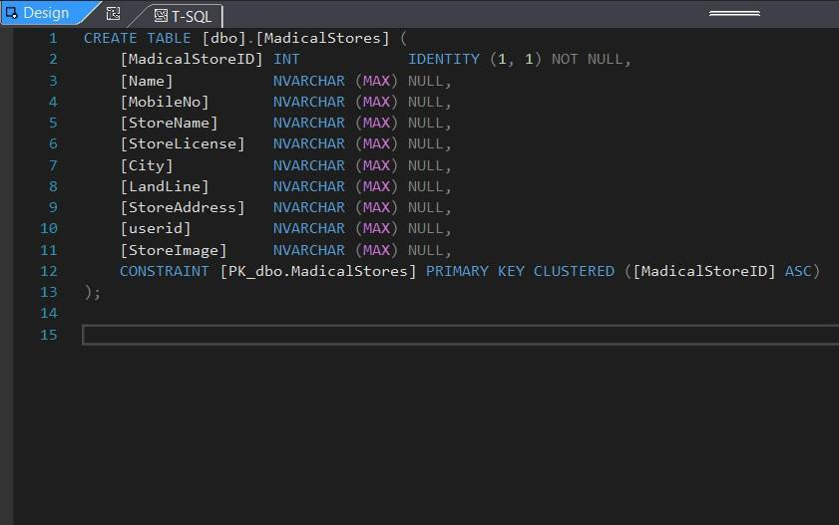

## Data Dictionary

**Table_User**

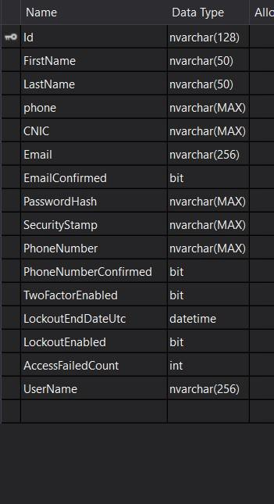

**Table_Product**

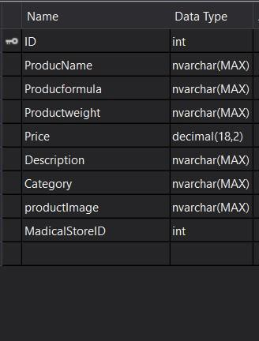

**Table_Roles**

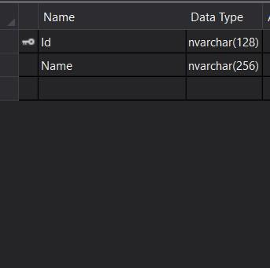

**Table_Medical Store**

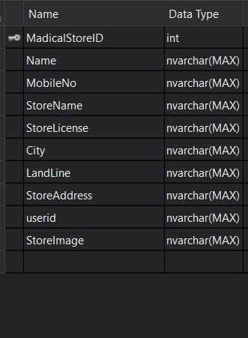

## Component Design

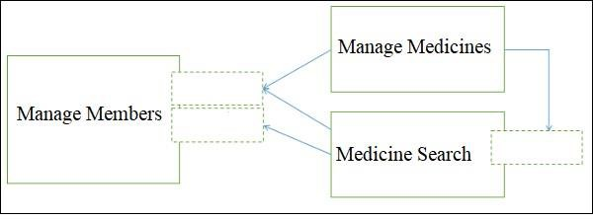

# Chapter 4

# Implementation and Testing

## Code Modules

* **Registration Activity**

Registration Activity Store the Information in the database of the user such as user name ,user email, user password ,user mobile number .

* **Login Activity**

Login Activity Authenticate the Information from the database of the user such as user email, user password.

* **Reset Password Activity**

Reset Password Activity Authenticate the Information from the database of the user such as user email and send the reset password to user email . • **Add Medicine Activity**

In this activity register user can add medicine on the portal which will be visible on visitors page.

* **Search Medicine Activity**

In this activity visitor will be able to find his/her desire medicine by formula, name, company and put filter by area.

* **Block Member Activity**

In this activity admin will be able to block a member who will violate the policies.

## Database Connectivity

* Database Microsoft SQL is used, for query entity framework is used and LINQ is used for retrieving data from DB.
* We will connect our application to database by establishing connection string of database server in web.config and we will execute quires by context classes of c#.

## Overview of User Interface

All screens and mockup will be user friendly. This interface will include learning ability as much as possible. We will create UI by using HTML, CSS, Bootstrap and Adobe Photoshop.

## Screen Images

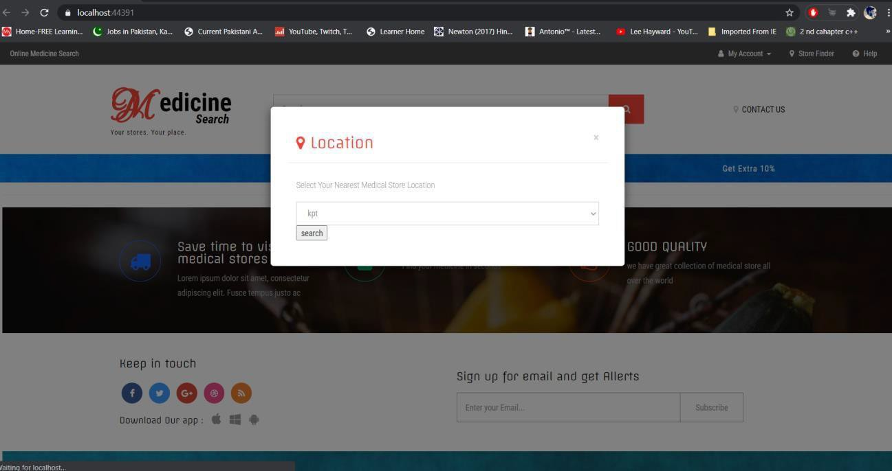

## Screen Objects and Actions

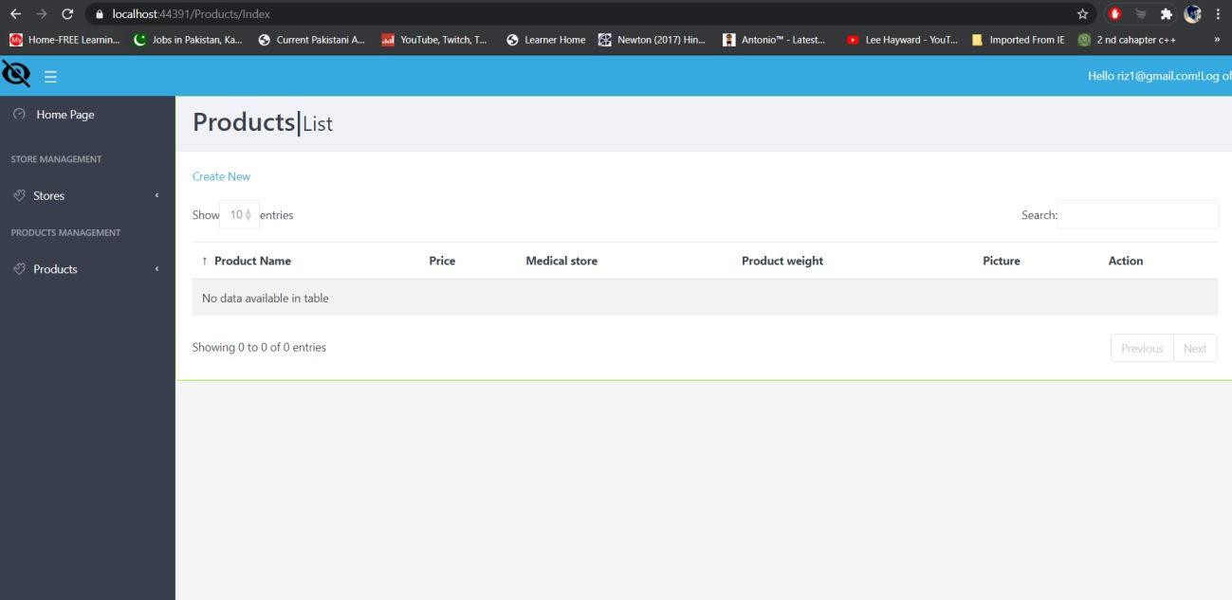

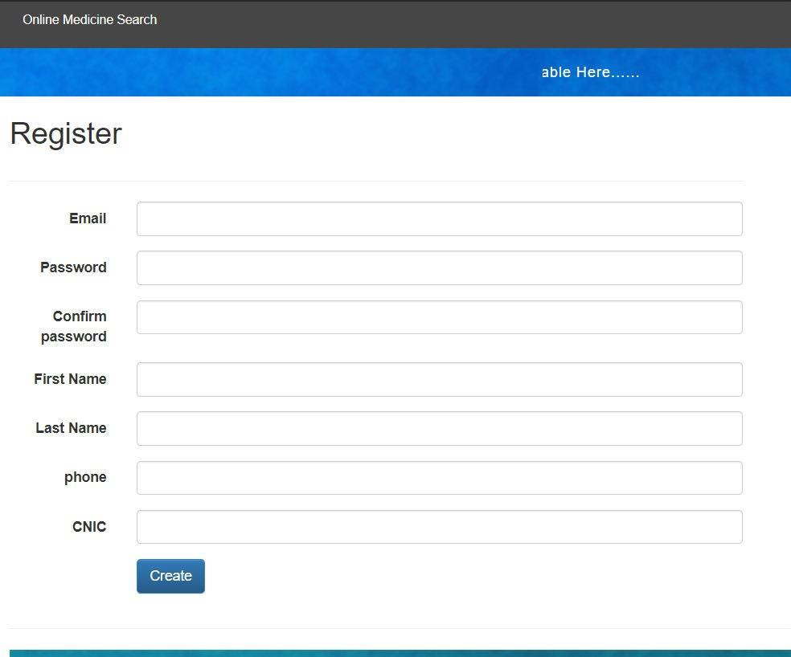

## Test Cases

### Test Case of Registration (Success)

|  |  |
| --- | --- |
| Screen Name | Registration Screen |
| Test Case ID | TC:01 |
| Engineer | M. Wasif Rehan |
| Application Name | Online Medicine Search |
| Testing Cycle | 01 |
| Scenario | Check Registration functionality |
| Environment | Web Browser Microsoft SQL server |
| Pre-Requisite | No |
| Strategy | Click On Exe File |
| Expected Result | Dashboard will Display |
| Observations | Screen width may be ask to you in case of running by exe file |
| Result | NO bug on Registration Screen |

### Test Case of Registration (Empty fields)

|  |  |
| --- | --- |
| Screen Name | Registration Screen |
| Test Case ID | TC:02 |
| Engineer | M. Wasif Rehan |
| Application Name | Online Medicine Search |
| Testing Cycle | 01 |
| Scenario | Check Registration functionality |
| Environment | Web Browser Microsoft SQL server |
| Pre-Requisite | No |
| Strategy | Click On Exe File |
| Expected Result | Dashboard will Display |
| Observations | Screen width may be ask to you in case of running by exe file |
| Result | Error message fill required fields |

### Test Case of Registration (Fail )

|  |  |
| --- | --- |
| Screen Name | Registration Screen |
| Test Case ID | TC:03 |
| Engineer | M. Wasif Rehan |
| Application Name | Online Medicine Search |
| Testing Cycle | 01 |
| Scenario | Check Registration functionality |
| Environment | Web Browser Microsoft SQL server |
| Pre-Requisite | No |
| Strategy | Click On Exe File |
| Expected Result | Dashboard will Display |
| Observations | Screen width may be ask to you in case of running by exe file |
| Result | Data not save in database due to technical isssue |

### Test Case of Login (Login Success)

|  |  |
| --- | --- |
| Screen Name | Login Screen |
| Test Case ID | TC:01 |
| Engineer | M. Wasif Rehan |
| Application Name | Online Medicine Search |
| Testing Cycle | 01 |
| Scenario | Checking login functionality |
| Environment | Web Browser Microsoft SQL server |
| Pre-Requisite | No |
| Strategy | Click On Exe File |
| Expected Result | Admin Screen Will Display |
| Observations | Screen width may be ask to you in case of running by exe file |
| Result | NO bug on Login Screen |

### Test Case of Login (Empty fields)

|  |  |
| --- | --- |
| Screen Name | Login Screen |
| Test Case ID | TC:02 |
| Engineer | M. Wasif Rehan |
| Application Name | Online Medicine Search |
| Testing Cycle | 01 |
| Scenario | Checking login functionality |
| Environment | Web Browser Microsoft SQL server |
| Pre-Requisite | No |
| Strategy | Click On Exe File |
| Expected Result | Admin Screen Will Display |
| Observations | Screen width may be ask to you in case of running by exe file |
| Result | Error message fill the required fields |

### Test Case of Login (Login failed)

|  |  |
| --- | --- |
| Screen Name | Login Screen |
| Test Case ID | TC:03 |
| Engineer | M. Wasif Rehan |
| Application Name | Online Medicine Search |
| Testing Cycle | 01 |
| Scenario | Checking login functionality |
| Environment | Web Browser Microsoft SQL server |
| Pre-Requisite | No |
| Strategy | Click On Exe File |
| Expected Result | Admin Screen Will Display |
| Observations | Screen width may be ask to you in case of running by exe file |
| Result | Invalid inputs |

### Test Case of Medicine Search (Success)

|  |  |
| --- | --- |
| Screen Name | Home Screen |
| Test Case ID | TC:01 |
| Engineer | M. Wasif Rehan |
| Application Name | Online Medicine Search |
| Testing Cycle | 01 |
| Scenario | Checking searching functionality |
| Environment | Web Browser Microsoft SQL server |
| Pre-Requisite | No |
| Strategy | Click On Exe File |
| Expected Result | Search Screen Will Display |
| Observations | Screen width may be ask to you in case of running by exe file |
| Result | Display search medicinde |

### Test Case of Medicine Search (Search bar empty)

|  |  |
| --- | --- |
| Screen Name | Home Screen |
| Test Case ID | TC:02 |
| Engineer | M. Wasif Rehan |
| Application Name | Online Medicine Search |
| Testing Cycle | 01 |
| Scenario | Search bar visible and button is shown |
| Environment | Web Browser Microsoft SQL server |
| Pre-Requisite | No |
| Strategy | Click On Exe File |
| Expected Result | Search Screen Will Display |
| Observations | Screen width may be ask to you in case of running by exe file |
| Result | Empty search bar |

### Test Case of Medicine Search (Data not found)

|  |  |
| --- | --- |
| Screen Name | Home Screen |
| Test Case ID | TC:03 |
| Engineer | M. Wasif Rehan |
| Application Name | Online Medicine Search |
| Testing Cycle | 01 |
| Scenario | Search bar visible and button is shown |
| Environment | Web Browser Microsoft SQL server |
| Pre-Requisite | No |
| Strategy | Click On Exe File |
| Expected Result | Search Screen Will Display |
| Observations | Screen width may be asking to you in case of  running by exe file |
| Result | Display message Search not found |

**Appendix I**

# <https://www.tutorialspoint.com/asp.net/index.htm>

# <https://www.tutorialspoint.com/software_engineering/index.html>